

Department of Computer Engineering & Technology

CSE

Capstone Project Synopsis - Level 2

Group No: | Students names | PRN | Email, Mobile number | Panel | Sign of student
P48 | Vijit Ayush Pandey | 1032222264 | 1032222264@mitwpu.edu.in  9359604013 | H | 
P48 | Sanskruti Rajesh Ninawe | 1032222499 | 1032222499@mitwpu.edu.in  8468889866 | H | 
P48 | Jinesh Nanal | 1032222029 | 1032222029@mitwpu.edu.in  8087688956 | I | 
P48 | Priyal Jain | 1032222475 | 1032222475@mitwpu.edu.in  9910730231 | H | 

Name of Guide: Dr. Shilpa Paygude
Project Title: An Intelligent Smart Helmet for Offline Navigation and Rider Safety
Project Domain: Head-Up Display (HUD) Systems, Internet of Things (IoT), Physical Artificial Intelligence, Embedded Algorithms, Sensor Fusion, Computer Vision
Name of the Company (for Industry Supported Project only): Not Applicable
Name of the External Guide (for Industry Supported Project only): Not Applicable
Inhouse project: NO

Abstract:
Two-wheeler riders increasingly depend on digital navigation and safety systems, yet most existing solutions are designed for smartphones and assume uninterrupted GPS and network connectivity. In real-world riding conditions such as tunnels, hilly terrain, dense urban corridors, remote highways, and low-visibility environments, these assumptions often fail. Riders are left without reliable navigation, limited situational awareness, and delayed access to emergency assistance, increasing both cognitive load and safety risk.
This project presents a Physical AI–enabled smart helmet designed to function as an independent, wearable assistance system for navigation, situational awareness, and rider safety. The helmet integrates motion sensors, vision modules, and a head-up display (HUD) to continuously perceive rider movement and the surrounding environment. When GPS connectivity is available, the system operates in a synchronized navigation mode; during GPS loss, it transitions seamlessly to an offline localization mode using sensor fusion, dead-reckoning, and map-based constraints to maintain approximate positional awareness and route guidance.
In addition to navigation, the system enhances rider safety through vision-based obstacle monitoring, real-time speed and status visualization on the helmet HUD, and an accident detection mechanism capable of identifying abnormal motion patterns. In the event of a potential crash, the system can trigger emergency response workflows, including SOS alerts, to reduce response time and improve post-accident outcomes.
The overall system is designed using an ISA-95–inspired physical architecture, enabling clear separation between physical sensing, real-time perception, operational decision-making, and planning and analytics layers. The proposed solution emphasizes low-cost hardware, modular software design, and vehicle independence, making it suitable for large-scale adoption. This project demonstrates how Physical AI, embedded algorithms, and intelligent human-machine interfaces can be combined to create a practical, safety-oriented smart helmet platform with strong potential for real-world deployment, future research, and product development.

Project Objectives for Team (at least 4 Objectives)-

- To design and develop an intelligent smart helmet capable of providing navigation assistance independent of continuous GPS and network connectivity.
- To implement offline localization using sensor fusion, dead-reckoning, and map-based correction techniques.
- To enhance rider safety through real-time situational awareness, obstacle monitoring, and HUD-based information visualization.
- To detect accidents and abnormal motion patterns and trigger timely emergency response mechanisms.
- To design a modular, low-cost, and scalable Physical AI system suitable for real-world deployment.

Individual Project Objectives per Team member
Sanskruti Rajesh Ninawe – Navigation & Route Intelligence Module
Sanskruti will design and implement the route processing engine within the mobile application, including map integration, polyline decoding, turn extraction, and offline route caching. This module ensures structured turn-by-turn instruction generation and logical route validation during network interruptions.
Vijit Ayush Pandey – Sensor Fusion & Localization Module
Vijit will develop the localization engine inside the mobile application using smartphone inertial sensors. This includes orientation estimation, heading tracking, dead reckoning for displacement during GPS loss, and map-matching techniques to reduce accumulated drift.
Priyal Jain – Embedded Systems & Application Interface Module
Priyal will develop the helmet-mounted embedded system, including Bluetooth communication, LED control logic, and onboard instruction parsing. In parallel, this member will contribute to mobile application development by implementing the user interface for real-time navigation feedback and device connectivity management.
Jinesh Nanal – Communication Protocol, Application Integration & Performance Optimization Module
Jinesh will design the inter-device communication protocol between the mobile application and helmet device, including packet structuring, synchronization, and error handling mechanisms. Additionally, this member will contribute to application-level integration, system optimization, structured field testing, and quantitative performance evaluation under GPS-denied scenarios.

H/w & S/w Requirements:
Hardware Requirements (High-Level)
- Helmet-mounted sensing module integrated into a smart helmet
- Forward-facing camera to observe rider motion and environment
- Motion sensing unit (accelerometer and gyroscope) for tracking movement and orientation
- Compact processing unit capable of real-time computation under limited resources
- Display unit integrated into the helmet (e.g., visor or small screen) for navigation feedback
- Local storage for offline map data and system logs
- Battery and power management system suitable for wearable use
Software Requirements (High-Level)
- Lightweight embedded operating system or runtime environment
- Sensor data acquisition and synchronization software
- Movement estimation and position tracking modules
- Offline map access and data management system
- Location alignment and correction logic based on map constraints
- GPS signal monitoring and mode-switching mechanism
- User interface software for displaying navigation and system status on the helmet display

High-Level Design [Architecture diagram/block diagram]:

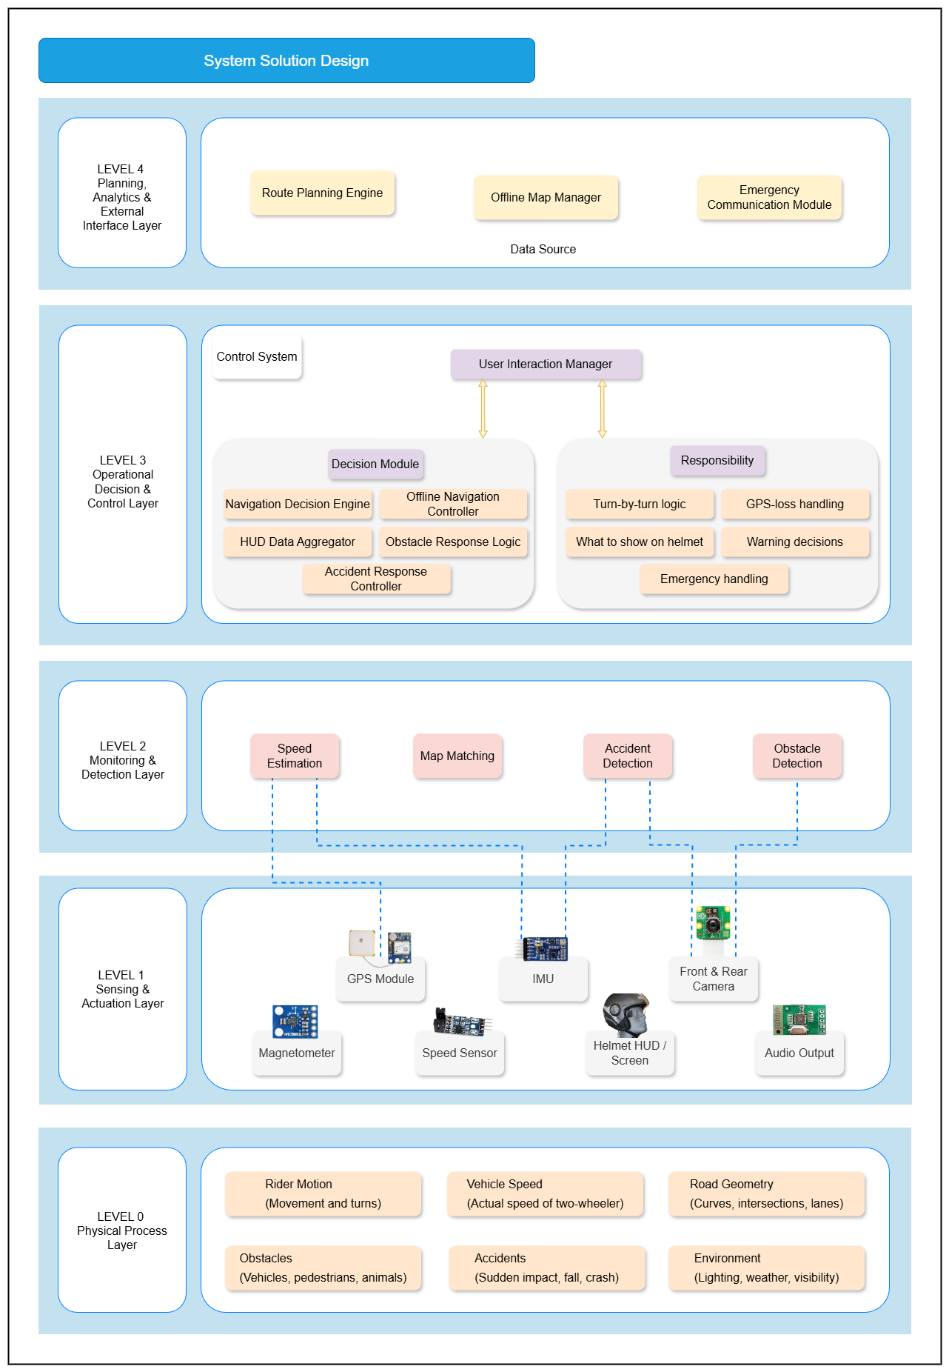

Working:

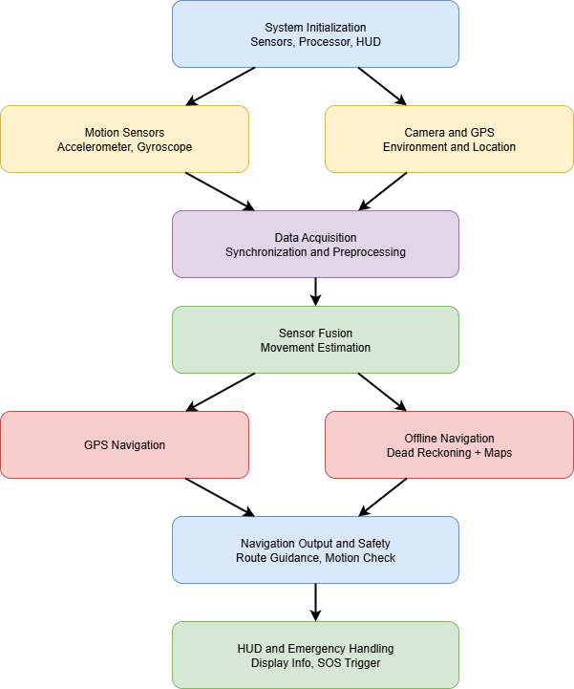

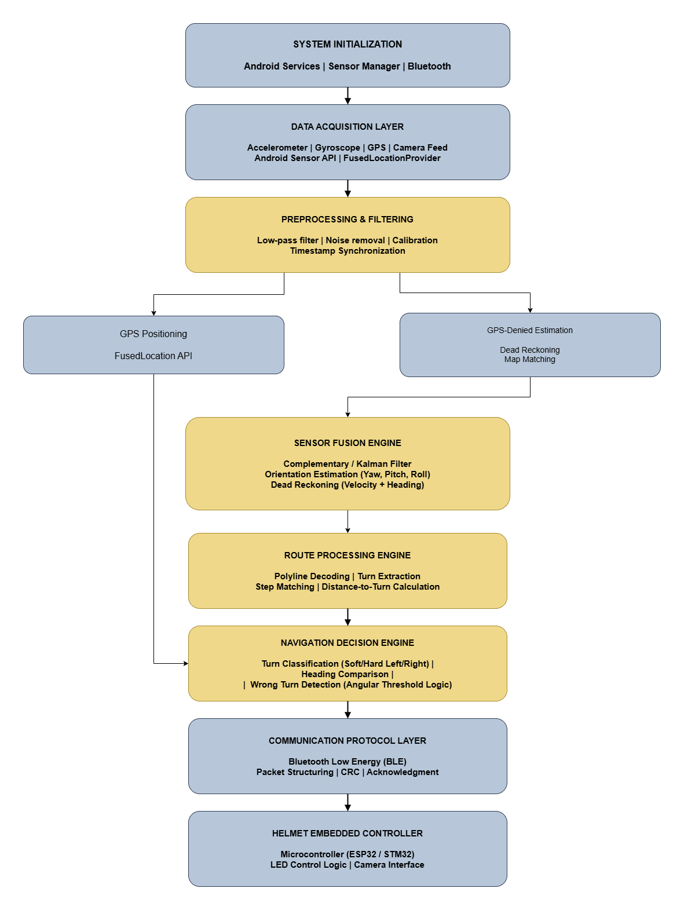
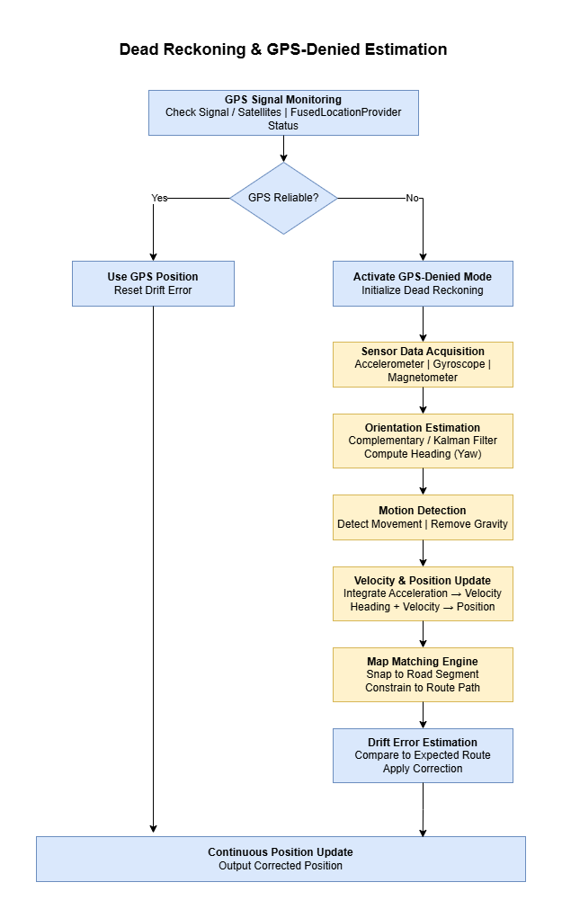

Name & Sign of the Guide

